Lab 26-1 | Configuring Drilldowns
Objective: To configure drilldowns and the thread bar. |  |  25-30 minutes

Instructions:
In your custom application, your users have a need to drill down on a service request number to see the Service Request Related SR View, and drill down on the product name in the XYZ Asset Data List Applet to see the product. In this lab you will configure object definitions to enable this desired drilldown behavior.

First, you will configure a drilldown so that clicking the service request number field (in certain views) will display the Service Request Related SR View for that service request. Then you will configure a drilldown in the XYZ Asset Data List Applet so that drilling down on the product name hyperlink field will display the Product Detail Key Features View.

1. Examine the drilldown behavior in the standard Siebel application. As you complete the step, notice the differences between the Service Request Detail View and the Service Request Related SR View. The first view you access will display the standard list applet on top with its related detail form applet below. The second view displays the detail form applet on top with detail categories below. You will modify this behavior in this lab so that the user drills down to the Service Request Related SR View.
- Log in to Siebel Call Center application and navigate to Service Requests > Service Request List.
- If necessary, add a service request record.
- Drill down on SR #. What view does it take you to?

- From the Site Map, navigate to Service Requests > Service Request List > Related SRs. Which view appears?

- Log out of the application.

  - Modify the drilldown object definitions to enable drilling down from the Service Request List Applet to the Service Request Related SR View.
- In Siebel Tools, select Applet :: Service Request List Applet | Drilldown Object :: Original. Which view is listed in the View property?

- Modify the view to reflect the new drilldown.
i. Select Applet: Service Request List Applet. Right-click on the record and select Lock Object.
i. Select Applet: Service Request List Applet | Drilldown Object :: Original.
    - Change the View property to Service Request Related SR View.
- Compile the Service Request List Applet.
i. Right-click the Service Request List Applet and select Compile Selected Objects.
ii. Click Service Request List Applet in the window of the Object Compiler dialog box.
iii. Click Compile. Ensure Auto-start web client is enabled.
d. In Siebel Call Center, navigate to Service > Service Request List.
i. Drill down on an SR #.
ii. Do you see the Service Request Related SR View?

e. Log out of Siebel Call Center.
- Identify the view used when drilling down on the asset list.
  - In the application, navigate to Assets > List using the Site Map.
  - What applet is used to display the list?

  - Drilldown on the Product field of an asset record. What view appears?

  - Log out of the application.

- Gather the information required to configure the XYZ Asset Data List Applet so that users can drill down on the Product Name field in the applet in order to see product details. This drilldown involves going from an asset record to a product record and requires additional configuration. This is because you are drilling down to a different business component than where you started. Enter the information you gather into this diagram:
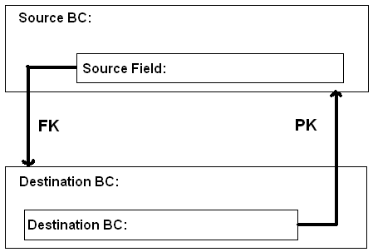

  - In Tools, select Applet :: Asset Mgmt – Asset List Applet | List :: List | List Column.
  - In the Display Name property, query for Product. This is the list column that contains the drilldown object. Note that the value in the Field property is Product Name, which is the BC field the list column references.
  - Select Applet :: Asset Mgmt - Asset List Applet | Drilldown Object.
  - Query the Hyperlink Field property for Product Name. The query should return a drilldown object whose name property is ProductToProductKeyFeatures.
  - Identify the source business component from which you are drilling down. It is displayed in the Business Component property of the Asset Mgmt - Asset List Applet. Enter it into the diagram.
  - Identify the destination business component to which you are drilling. It is displayed in the Business Component property of the ProductToProductKeyFeatures drilldown object. Enter it into the diagram.
  - Identify the source field that serves as the foreign key field to the destination business component. It is displayed in the Source Field property of the ProductToProductKeyFeatures drilldown object. Enter it into the diagram.
  - Identify the destination field that serves as the primary key field. It is displayed in the Destination Field property of the ProductToProductKeyFeatures drilldown object. Recall that the Id field is used by default when a field is blank.

- Configure the drilldown, using the information entered in the diagram above.
  - Select Applet :: XYZ Asset Data List Applet | Drilldown Object.
  - Add a new drilldown object definition using the property values in the table, below. Hyperlink Field specifies the list column or control that has hyperlink capabilities. View specifies the destination view when the hyperlink is clicked. Sequence specifies the order in which drilldown objects are activated when using dynamic drilldowns. In this case, we assign 1 since there are no other drilldown object definitions for this applet.
Property | Value
Name | Product
Hyperlink Field | Product Name
View | Product Detail Key Features View
Source Field | Product Id
Business Component | Internal Product
Sequence | 1

  - Compile the XYZ Asset Data List Applet. Ensure that Auto-start web client is not checked.

- Enable the XYZ Account Asset View to support the threadbar, which assists user navigation among views.
  - Select View :: XYZ Account Asset View.
  - Set the properties as shown in the table, below. The Thread Applet property specifies which of the applets appearing in the view will supply data for the thread field. Thread Field is the name of the field whose data is included in the arrow box, following Thread Title. Thread Field is in the business component related to the applet identified via Thread Applet. Thread Title is the text used in the thread to identify the view. To select the Thread Title value shown in the table, enter Account into the Starting with window in the pop-up pick list. Then select the first record in the list.
Property | Value
Thread Applet | Account Form Applet
Thread Field | Name
Thread Title – String Reference | Account (Select the first one in the list)

- Compile the XYZ Account Asset View.

- Add the Product Detail Key Features View to the XYZ Developer responsibility.
  - Log into Siebel Call Center application and navigate to Administration – Application > Responsibilities.
  - Add the Product Detail Key Features View to the XYZ Employee responsibility to ensure that SADMIN can see this view when testing the application.
  - Ensure the Local Access flag is checked.
  - Click Clear Cache.
  - Close the application.

- Test your work.
  - In the application, navigate to Accounts > Accounts List.
  - Create an account record.
  - Drilldown on Account Name.
  - Click the Assets view tab.
  - Create an asset record by entering Ctrl+N in the Assets view.
    - Select the Product Name field.
    - Click the MVG button and then click Go.
    - Click the OK button to select the first record in the list.
    - Step off the record to save it.
  - Ensure that the Product Name field is hyperlinked. Compare your view against the screen print below.

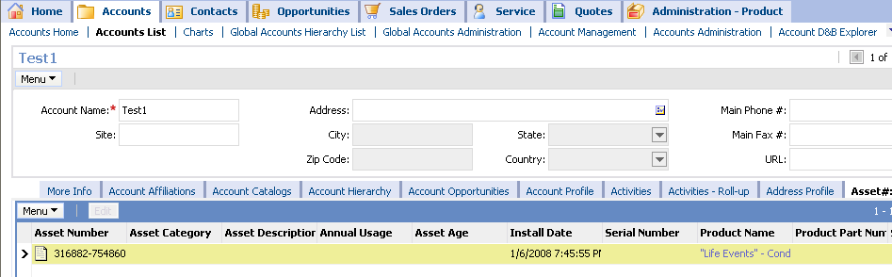

  - Drill down on the Product Name. Do you see the Product Detail Key Features View? Compare with the screen shot below.

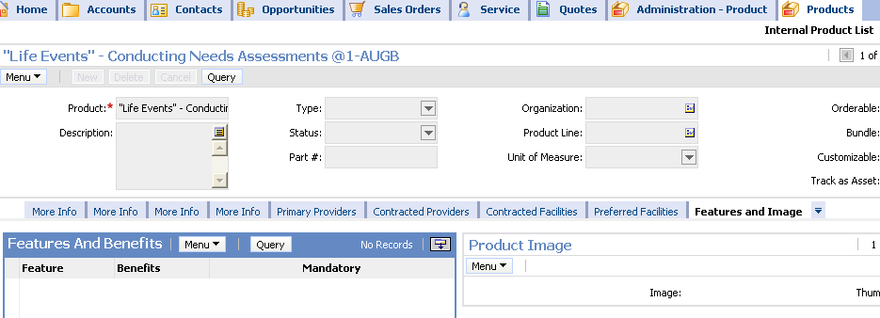
  - Log out of Siebel Call Center.

Solutions Lab 26-1 Configuring Drilldowns

1.c Service Request Detail View.

1.d Service Request Related SR View.

2.a Service Request Detail View.

2.d.ii Yes.

3.b Asset Mgmt – Asset List Applet.

3.c Product Detail Key Features View.

4.


